Canny Edge Detection
code:
import cv2
import matplotlib.pyplot as plt
image = cv2.imread('max.jpg', cv2.IMREAD_GRAYSCALE)
blurred = cv2.GaussianBlur(image, (5, 5), 1.0)
edges = cv2.Canny(blurred, 100, 200)
plt.figure(figsize=(12, 6))
plt.subplot(1, 2, 1)
plt.title("Original Image")
plt.imshow(image, cmap='gray')
plt.axis('off')
plt.subplot(1, 2, 2)
plt.title("Canny Edge Detection")
plt.imshow(edges, cmap='gray')
plt.axis('off')
plt.show()
cv2.imwrite('canny_max.jpg', edges)
Code Explanation
- Image Preprocessing:
  - Load the image in grayscale mode for single-channel edge detection.
  - Apply a Gaussian blur to reduce noise and smooth the image, which improves edge detection accuracy.
- Canny Edge Detection:
  - Use OpenCV’s cv2.Canny function for edge detection.
  - Set two thresholds:
    - Lower threshold: 100
    - Upper threshold: 200
  - These thresholds define which gradient magnitudes are considered as edges.
- Visualization and Saving:
  - Display the original and edge-detected images side by side.
  - Save the output image as canny_max.jpg.
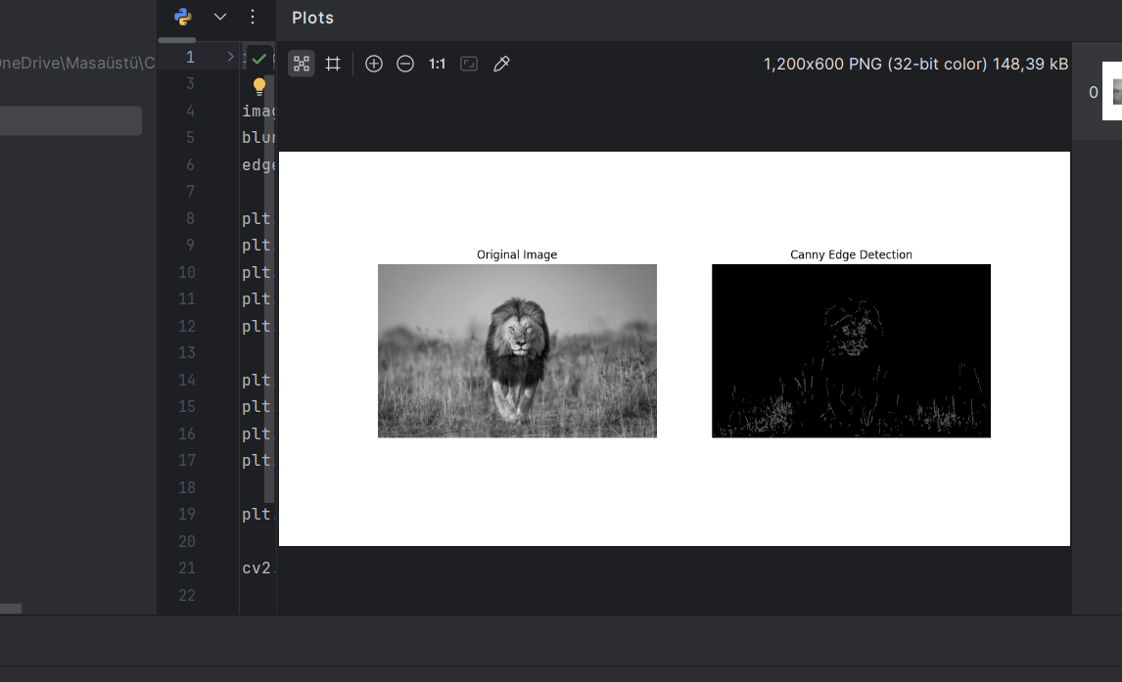
output:

Report
Objective
To apply the Canny Edge Detection method on the image max.jpg to identify and visualize edges effectively.
Process
- Gaussian Smoothing:
  - Smoothens the image to reduce noise and minor variations in pixel intensity.
  - Ensures edge detection focuses on meaningful intensity changes.
- Gradient Computation:
  - The Canny algorithm calculates gradients to identify regions of rapid intensity changes.
  - These gradients represent potential edges.
- Thresholding:
  - The double thresholding mechanism ensures strong edges are preserved while weak edges are connected to strong ones if they form a continuous boundary.
  - Threshold values (100, 200) are selected to balance sensitivity and specificity.
- Edge Linking:
  - Identifies edges based on connectivity, ensuring a clean and coherent edge map.
Results
- The Canny edge-detected image (canny_max.jpg) shows sharp, well-defined edges.
- Strong object boundaries are clearly visible, while noise and minor variations are suppressed.
Conclusion
Canny edge detection provided robust edge detection for the image max.jpg, effectively balancing noise suppression and edge preservation.
Recommendations
- Adjust the threshold values based on image characteristics (e.g., increase upper threshold for low-contrast images).
- Experiment with different Gaussian kernel sizes for varying levels of smoothing.

